AFRICAN UNION |  | UNION AFRICAINE
 |  | UNIÃO AFRICANA

ITEMS SPECIFICATIONS & IMAGES

S/N | ITEM NAME | IMAGE | SPECIFICATIONS
1 | HD ID dual sided printer | 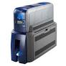 | - HD dual sided printer with printing software;  - Print speed 1200 cards per 8 hours.  - Magnetic strip encoding  - Dual card input hopper.  - Model part number 525302-003
2 | Laminator machine | 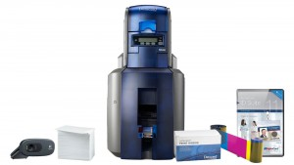 | - SD3 Laminate Module,  - Dual sided,  - Part number 529464-002
3 | Entrust data card SD460 printer colour ribbon. | 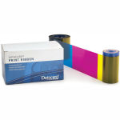 | - Entrust data card SD460 printer colour ribbon  - Part number RD534000-008.  - 500 prints per roll single dual and 250 dual.  - For SP Plus and SP460 Printers
4 | Datacard SD460 over Laminate film | 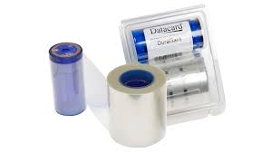 | - Entrust datacard duraguard laminate partnumber RD508668-001, 0.5mil cover film.  - Full card, Optiselect, custom hollow,  - Random security design  - 350 prints per roll for SD, CD and SR Printers.
5 | Sigma DS3 Printer Ribbon | 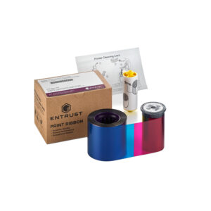 | - Entrust data card Sigma DS3 printer colour ribbon number 525100-004-S100.  - Capable to print bar codes and monochrome graphics with protective coating.  - Printing 500 prints and 250 dual sided.
6 | Sigma DS3 Printer over Laminate film | 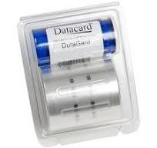 | - Duraguard laminate, 1.0mil full card,  - Protecting against abrasion, moisture, scratch resistant, 350 prints.  - Film Sigma DS3 part number 508668-701.
7 | Blank ID Cards HID UltraCards Premium (Number 082137) classic | 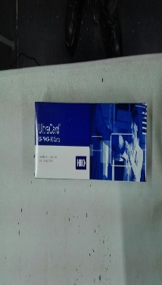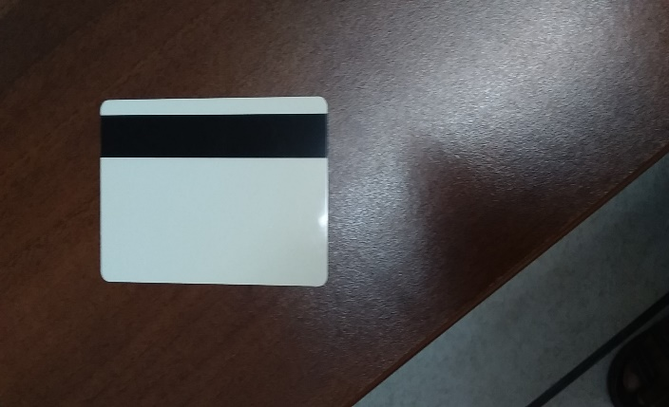 | - Blank White ID Cards HID UltraCards Premium – Hi coercivity magnetic strip (Number 082137)  - Certified ISO CR- 80 Composite HID cards, semi-flexible PVC plastic,  - Printable with SD460, DS3 and fargo 5000 printers,  - Size- 85.6 x 54mm.  - 500 per box, High card durability;
8 | Adhesive cleaning sleeve kit part number 552141-002 | 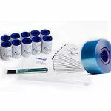 | - Adhesive cleaning sleeve and isopropanol cleaning card,  - Compatible with datacard SD460 part number 552141-002
9 | Sigma SD3 cleaning kits | 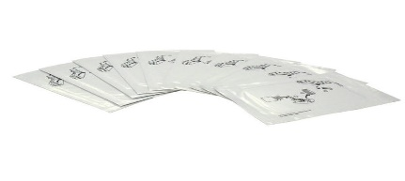 | - Sigma SD3 cleaning kit (Number 507377-001)  - Isopropanol swabs (10 double sided per pack) count. One year shelf life.
10 | Vertical ID Card Holders | 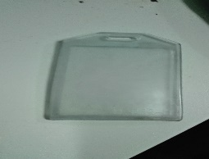 | - Vertical ID card plastic holders  - Flexible durable plastic  NB Sample required
11 | Lenyards | 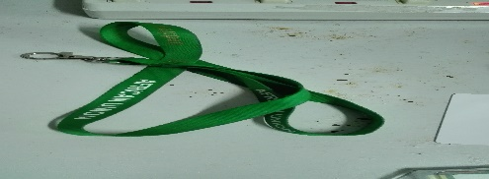 | - AU Logo embedded lanyards  - On AU green background lenyard;  - Length 82cm straight and 41cm folded;  - Width 2cm;  NB Sample rquired.
12 | ID Badging Camera | 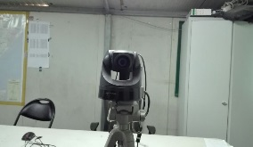 | -USB Valcam ID Badging camera ;  -Model 8500-630  -Complete with accessories (data cable etc)
13 | 1 terabite USB external drive for ID System | 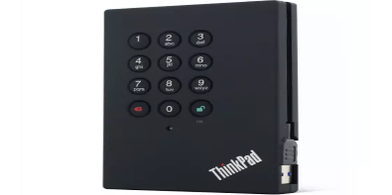 | - High level 256 – bit encryption standard (AES),  - Intergrated, metal dome switch keypad entering 8-16 digit password,  - Connectivity via USB2.0, 3.0 port or cable, complete with a USB-Y cable with carrying case.

